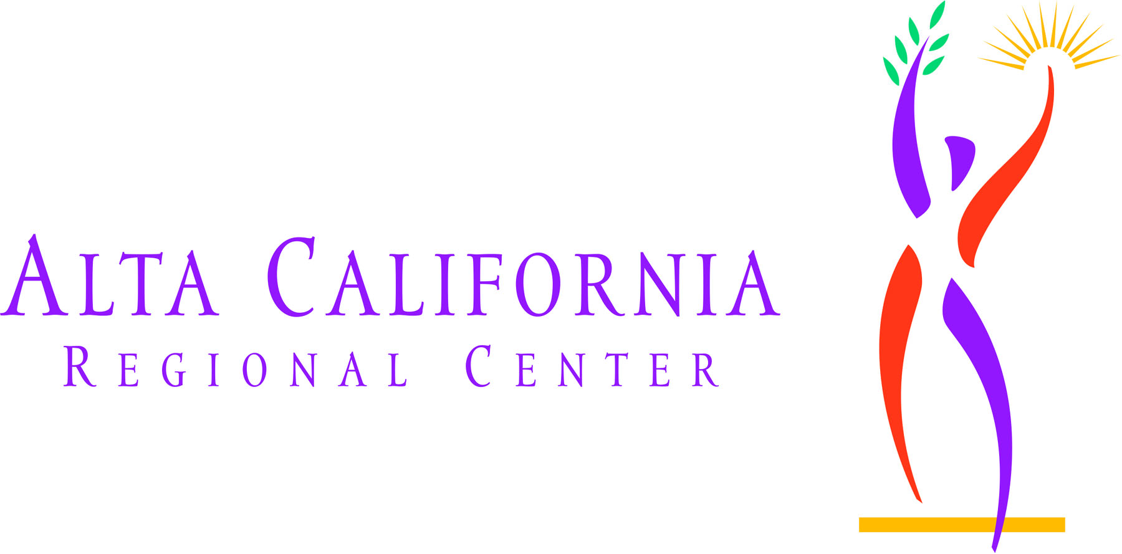

Procedures Manual

Personal Attendant/Homemaker Service
(Nonmedical Services)

Definition
Non medical personal assistant services are intended to promote living in the least restrictive setting which is age-appropriate, and community-based. ACRC recognizes that clients may have ongoing or time-limited need for personal support and assistance in order to maintain their current living arrangement. These services may be provided for:

Personal Support and Assistance
- Adult clients living independently;
- Adult clients residing with a parent/family member caring for them in the family home;
- Adult clients living or participating in activities located in environments other than residential or day services (limited circumstances) when no other options are available. (Ex: Personal care needs in a college setting.)

Personal Assistance Needs Defined
Personal Care Needs are intimate and immediate physical and personal needs such as eating, toileting, dressing, grooming and hygiene. These needs are otherwise referred to as Activities of Daily Living (ADL) and include the following:
- Bathing: Cleaning the body using a tub, shower or sponge bath, including getting a basin of water, managing faucets, getting in and out of a tub or shower, reaching head and body parts for soaping, rinsing and drying.
- Dressing: Putting on and taking off, fastening and unfastening garments and undergarments and special devices such as back or leg braces, corsets, elastic stockings/garments and artificial limbs or splints.
- Toileting: Getting on and off a toilet or commode, emptying a commode, managing clothes, wiping and cleaning the body after toileting, and using and emptying a bedpan and urinal.
- Transferring: Moving from one sitting or lying position to another sitting or lying position (e.g., from bed to or from a wheelchair, or sofa, coming to a standing position and/or repositioning to promote circulation and to prevent skin breakdown).
- Continence: Ability to control bowel and bladder as well as to use ostomy and/or catheter receptacles, and to apply diapers and disposable barrier pads. Limited to external care of ostomy site and changing of catheter bags.
- Eating: Reaching for, picking up, grasping a utensil and cup; getting food on a utensil; bringing food, utensil and cup to mouth; manipulating food on a plate; and cleaning face and hands as necessary following a meal.

Other Personal Assistance
These supports refer to assistance provided to a client to maintain his/her current living setting and may include:
- Assisting with common daily living activities such as meal preparation, including planning, shopping, cooking, clean-up and storage activities.
- Performing routine household activities aimed at maintaining a clean, orderly and safe environment within the home, such as bed making, dusting, laundry, and vacuuming.
- Assisting with medical appointments which may include attending the medical appointment or coordinating and providing transportation when needed, after all generic resources have been exhausted.
- Assisting clients with coordinating transportation for errands such as bill paying, picking up medications, and banking.

Generic Resources/Natural Supports/Circle of Support
All appropriate generic resources must be explored and integrated into the developed IPP plan. They will be considered as part of the progress review on a regular basis to determine maximum utilization and reduce ACRC purchase of services, if at all possible, while maintaining the quality and integrity of the services for the client. Prior to ACRC funding, all contacts with generic services and natural supports must be documented.

Generic resources are defined as "voluntary service organizations, commercial businesses, nonprofit organizations, generic agencies, and similar entities in the community whose services and products are regularly available to those members of the general public needing them." Examples include but are not limited to In-Home Support Services (IHSS), Mental Health, medical services, community centers and colleges, recreation leagues, food closets, special utility rates, adaptive equipment, and home modifications.

Typically, these types of personal support and assistance services most commonly may be available from the following generic services:
- In-Home Supportive Services (IHSS) Program; and/or
- Medi-Cal Programs including EPSDT and Nursing Waiver

Natural supports are defined as "associations and relationships typically developed in the community that enhance or maintain the quality and security of life for people."
It is the responsibility of the Service Coordinator (SC) and Planning Team to ensure that all natural supports and generic services are utilized prior to purchasing services.

Circle of Support means a committed group of community members, including family members, meeting regularly with an individual with developmental disabilities in order to assist the individual in establishing and maintaining natural supports and who do not receive payment for participation in the circle of support.

Regional Center (RC) funds shall not be used to supplant the budget of any agency which has a legal responsibility to serve all members of the general public and is receiving funds for providing those services.

Least Costly Service
ACRC will purchase services from the least costly service provider that can reasonably meet the client’s needs. Determination of least costly provider will include:

- Provider rates
- Comparable services
- Cost of transportation
- Medicaid Waiver eligibility
- Geographic area of residence

The client will not be required to use the least costly option if that option results in a more restrictive living arrangement or a less integrated service setting. If the service option is not the least costly option the case will be sent to Best Practice for review.

Key Considerations for Services
- This is a “care” rather than a “training” model. There may be other services and/or supports that can be accessed if the client can benefit from training or adaptive technology while temporary personal assistance services are in place.
- SCs should review the plan at least every 6 months for level of care or quarterly if residing independently. If the service is provided by an individual personal assistant, the Service Coordinator will annually obtain a copy of automobile insurance and driver’s license, or California ID if not transporting the client, to be forwarded to CSS.
- This service may be purchased by the regional center only when the planning team determines the additional services are consistent with the provisions of the client’s Individual Program Plan (IPP).
- IHSS is the primary generic resource available to clients. In order to obtain this service IHSS must be maximized. If the client does not receive the maximum hours allotted by IHSS a redetermination assessment shall be requested and documented as part of the plan for purchasing personal assistance hours from ACRC. IHSS hours are to be used as intended and prescribed by the social services worksheet.
- If the client is ineligible for IHSS and is receiving SSI and Medi-Cal benefits a review of all benefits received by the client will be required.
- Clients will be required to access and maximize any Federal Waiver hours they maybe eligible for. Documentation of the Federal Waiver hours will be requested for review.
- The service will be at least as cost-effective as any available community-based alternative.
- The need for the service is agreed to by the client and/or family through the planning team process and will not be used for respite.
- The client shall not be able to receive personal assistance and homemaker service as a choice in lieu of accessing the generic services of IHSS or Federal Waiver programs.
- The client’s IPP includes an objective(s) which can be met by the purchase of personal assistance and/or homemaker service.
- These services shall not duplicate those already being purchased by ACRC or other public entities.
- Service Codes 520 (ILS agency) or 635 (ILS specialist) will not be used in lieu of the provisions of this service to provide care.
- This service shall not be used to supplant natural supports offered by primary caregivers, parents, roommates, housemates, or other family members residing in the same home.
- Individuals providing the service may not reside in the same home with the client.
- This service is not intended for management of behavior, medical care, treatment, or administration of medications.

Service Code Options
- Personal Assistance – Individual (Service Code 062)
“Personal Assistance – Individual” provides personal assistance and support to ambulatory and non-ambulatory clients. This service type/code is not defined in regulation and is referred to as a “miscellaneous service.”
This service provides assistance with ADL skills, meal preparation, and housekeeping chores which are incidental to the care furnished, or are essential to the health and welfare of the individual, rather than the individual’s family.
2. Homemaker Service (Service Code (860)
A “Homemaker Service” employs, trains, and assigns personnel who maintain, strengthen, or safeguard the care of individuals in their homes. The staff providing the services must meet qualifications and training established by agency guidelines. This service provides assistance with ADL skills, meal preparation, and housekeeping chores which are incidental to the care furnished, or are essential to the health and welfare of the individual, rather than the individual’s family.

Amount of Service
For clients residing in the home of a family member:

The initial request shall be reviewed and approved by Family Support Services Committee (FSSC).

For clients who do not qualify for daycare services and are not eligible for IHSS but still require care and supervision due to primary caregivers’ work schedules, the amount of service is limited to no more than 40 hours per week, based on demonstrated need.

Service Initiation Process
- For clients who do not qualify for daycare services but still require care and supervision due to primary caregivers’ work schedules, the service initiation process is as follows:
  - The planning team determines that there are no appropriate generic resources or natural supports available.
  - SC will schedule to attend the Family Support Services committee.
  - Prior to the committee staffing, the SC will obtain the following:
    - A list of all current POS,
    - Primary caregivers work schedules (including work holiday schedule),
    - Schedule of IHSS utilization,
    - A copy of the IHSS Notice of Award,
    - Client’s day program schedule (including transportation time),
    - Schedule of natural support utilization, and requested amount of hours.
    - Documentation of any hours awarded through a Federal Waiver Program.
  - Based upon recommendation of committee, POS to be submitted.

Amount of Service
For clients who require support in out of home activities:

The initial request shall be reviewed and approved by Adult Services Committee

For clients who need support for personal care needs while participating in activities located in environments other than residential or day services, or who cannot be adequately supported by the available generic resources (such as college enabling centers). Homemaker/Personal Attendant services should not be used to supplement existing day program services. The amount of service will be dependent on assessed need and should not exceed 138 hours per month.
Personal Attendant/Homemaker service is not a training program and does not provide goals or review progress. If appropriate resources are unable to be accessed, the Planning team may consider the use of PA/Homemaker services as a creative option to address the needs of a client in a productive way until a day/vocational program becomes available. To utilize this service in lieu of day program, the team would first determine that there are no other appropriate alternative options available. The Service coordinator would identify the client’s unmet need on the Needs Assessment program in SANDIS. The service shall be cost effective as compared to a day program setting.

Service Initiation Process
- For clients who need support for personal care needs while participating in activities located in environments other than residential or day services or who can not be adequately supported by the available generic resources (such as college enabling centers) the service initiation process is as follows:
  - The planning team determines that there are no appropriate generic resources or natural supports available.
  - SC will schedule to attend the Adult Services committee.
  - Prior to the committee staffing the SC will obtain the following:
    - A list of all current POS,
    - Schedule of IHSS utilization,
    - A copy of the IHSS Notice of Award,
    - Client’s day schedule (i.e. college class schedule),
    - Information on what generic services and natural support can provide,
    - Requested amount of hours,
    - Documentation of any hours awarded through a Federal Waiver Program
    - Confirmation of SANDIS unmet needs documentation
  - Based upon recommendation of committee POS to be submitted.

Amount of Service
For clients residing in their own home:

For those clients who require a limited amount of additional support (up to 62 hours), in order to safely maintain their independent living situation, or to assist with managing a particular situation (such as attendant support with transportation and attendance at a medical appointment out of the area), approval may be given by the Client Services Manager. The Service Coordinator will complete the Personal Attendant Services Checklist and consult with their direct supervisor.

For those clients who need more than a limited amount of support, the initial request shall be reviewed and approved by Residential Living Options Committee.

For clients who need support to live independently, the amount of service is determined by assessed need, generic resources, and natural supports available to the client as well as cost effectiveness. This support may be purchased in addition to other regional center funded services, such as Independent Living Services or Supported Living Services with a Median rate vendor.

The need for homemaker/personal attendant services will be reviewed quarterly and the number of hours is dependent on the needs of the individual and the variables of generic resources and natural supports.

Service Initiation Process
- For clients who need support to live independently the service initiation process is as follows:
  - The planning team determines that the available generic resources and/or natural supports are insufficient to meet the needs, or the needs exceed the number of hours provided by Median Rate Supported Living provider or exceeds the parameters of the ILS service.
  - SC will schedule to attend the Living Options committee.
  - Prior to the committee staffing, the SC will obtain the following:
    - A list of all current POS,
    - Schedule of IHSS utilization,
    - A copy of the IHSS Notice of Award,
    - Client’s weekly schedule,
    - Information on what generic services and natural support can provide,
    - Requested amount of hours,
    - Documentation of any hours awarded through a Federal Waiver
    - If client is in SLS with Median rate SLS vendor, copy of current budget and staffing schedule and proposed schedule for Homemaker/PA support.
- Based upon recommendation of committee, POS to be submitted.

Amount of Service
- The SC and planning team may identify needs of the client or the family situation which maybe extraordinary and which may require an exception to the amount of service (See amount of service section for the specific usage). Requests for exception to Service Policy will be considered and require the review and approval of the Unit Supervisor and the Appropriate committee (if needed) and Best Practice approval (when needed). Client/family needs which exceed the service limitations will be considered on an exception basis through the appropriate committee and authorization process outlined in the General Standards for the Purchase of Services and Supports Policy and the General Standards for the Purchase of Services and Supports Procedure.

Evaluation of Service Effectiveness
- The SC will review and document the effectiveness of the personal assistance/homemaker service with the planning team semiannually (quarterly for individuals residing in their own homes). The review will be based upon the client’s IPP objectives, and should consider the following:
  - Continued use of personal assistance is deemed necessary and appropriate; and
  - The service is producing the desired outcomes consistent with the stated goals in the IPP.
  - Service provider’s reports substantiate the need for continuation of the service.
2. The POS for in home Personal Attendant services is to be reviewed by the Family Support Services committee at least annually.

Technical Support
All services provided by ACRC vendors must comply with approved standards of care and treatment and be within the scope of the approved program design or service delivery plan and intended parameters of the service code. Any issues or questions arising related to these standards, or deviations from the intended use of the service shall be referred to the Community Services and Supports Department for a Quality Assurance review and technical assistance.

Termination of Service
Notification to the client/family of a decision by ACRC to terminate a purchased service must be carried out in accordance with statute. The reason for termination should be documented in Title 19 notes.

Termination of purchased services will occur when:

- Reasonable progress on stated objectives cannot be achieved;
- The service no longer meets the client’s need;
- Health and safety concerns place the client at risk;
- Permission to access information related to the availability, types and amounts of generically available service is denied/revoked by the parent, the client, or legal representative;
- Client requires licensed residential care
- Client moves out of ACRC catchment area;
- Client dies;
- Confirmation that fraudulent use/application of the service has occurred on either the part of the provider or the recipient;
- Services provided no longer meet the parameters of the program statement, limitation of the service code of the vendor, or is no longer a cost-effective use of public resources; or
- When services are stopped with one provider and started with another, please submit a cancellation of the ending service along with the new POS for the new service prior to the start of the new service.

Authority
Welfare and Institution Code §§4512(b), 4512(e), 4512 (f), 4512(h), 4646.4(a)(4), 4659, and 4685 address the high priority placed on services and supports to allow clients to live in the community.
California Code or Regulations, Title 17, commencing with §54300 and including §§54302(a) (26), (32), (39), (57), 56704(a)(6), 54342(a)(31)(32)(33)
California Code or Regulations, Title 22, §80001(a)(1)

Additional Resources
http://www.altaregional.org/
http://www.dds.ca.gov/Statutes/GovernmentCode.cfm

