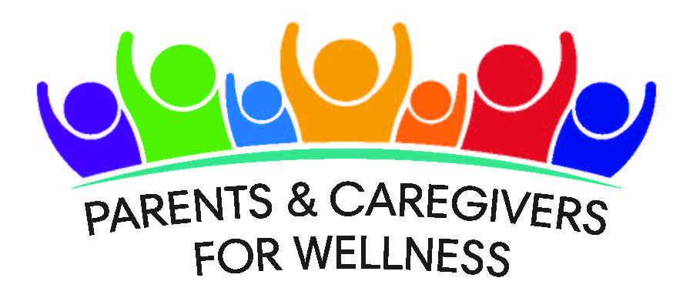

Parents and Caregivers for Wellness Survey

Greetings,
Parents and Caregivers for Wellness is a group of Parent/Caregiver run organizations from across California who are working together to improve behavioral health services and supports to children and their families.
Families are the best resource we have to identify the strengths and needs of California’s families. To help us understand what behavioral health services and supports are needed in California, we are asking that you fill out the following survey. The information you provide will help us develop training and advocacy activities.
We hope that you will provide us with your name and contact information at the end of the survey so that we can send you the results of this survey, keep you updated on our activities, and provide you with information that will help you and your family.
If you have any questions about this survey or want to know more about us, please call (805) 384-1555, email mhannah@unitedparents.org or look us up on Facebook or our website: https://parentscaregivers4wellness.org/

Thank you for your time.

United Parents
Capital Adoptive Families Alliance
California Alliance of Caregivers
California Mental Health Advocates for Children and Youth
East Bay Children’s Law Offices

General Information:

- Which city do you live in?
____________________________________________________

- Which county do you live in?
____________________________________________________

- What is the age of the child in your home requiring/receiving mental health services?
  - Birth to 3 years old
  - 4 to 5 years old
  - 6 to 11 years old
  - 12 to 15 years old
  - 16 to 18 years old
  - 19 to 20 years old
  - 21 to 24 years old
  - 25+

- What is your relationship to the child in your care? (check all that apply)
  - Adoptive parent
  - Biological parent
  - Foster parent/Resource parent
  - Relative Caregiver (grandparents, aunts, uncles, distant relatives or friend of the family)
  - Other__________________

- Which category best describes your child? (check all that apply)
- American Indian/Alaska Native
- Latino/Latina
- Hispanic
- Black/African American
- Asian
- Native Hawaiian/Pacific Islander
- White/Caucasian
- Middle Eastern
- Mixed race/multiracial
- Other ____________

- What kinds of concerns do you have about the child/children you care for regarding their physical/neurological health? (check all that apply)
  - Developmental disabilities
  - Autism
  - Insomnia
  - Being Bullied
  - Violence in the home/community
  - Special Education
  - None
  - Other _________________

- What kinds of concerns do you have about the child/children you care for regarding their mental health? (check all that apply)
  - Attention Deficit/Hyperactivity Disorder
  - Anxiety Disorders
  - Depression
  - Suicidality/Self Harm
  - Oppositional, Defiance and/or conduct challenges
  - Mood Disorders
  - Eating Disorders
  - Obsessive Compulsive Disorder
  - Attachment/Bonding challenges
  - Post-Traumatic Stress Disorder
  - Drug and/or alcohol use
  - None
  - Other _________________

- What kinds of concerns do you have about the child/children you care for regarding their behaviors? (check all that apply)
  - Harm to self/others
  - Temper Tantrums
  - Not following directions/inattention
  - Not sleeping
  - Defiant behaviors
  - Problems making friends
  - Problems getting along with siblings
  - None
  - Other__________

- Do you believe the physical, neurological, mental health and/or behavioral challenges are because of trauma?
  - Yes
  - No

- Are you receiving all of the services and supports you need for the child or youth you care for?
  - Yes (skip to question #13)
  - No (please answer #11 and #12)
  - Don’t know (please answer #11 and #12)

- If you answered “no” or “don’t know” to the question above, what services are you missing for your child? (check all that apply)
  - Respite
  - Quality child care
  - Appropriate therapy
  - Family advocate or partner
  - Wraparound Services or intense in-home treatment
  - Behavioral Support
  - Residential Program
  - Support group
  - Other_____________

- If you answered “no” or “don’t know” to the question above, why are you missing services? (Check all that apply)
  - I don’t know what is available to help me or how to find resources
  - Services not covered by insurance/can’t afford services
  - The services and supports I need are not available in my community
  - I get too overwhelmed
  - Not enough time in the day to access services/supports
  - I/my child are not eligible for programs we need
  - Slow process to receive services
  - Frequent change in service providers/high turnover
  - Other____________________________________________________________

- Are you receiving all of the services and supports you need for yourself?
  - Yes (skip to question #16)
  - No (please answer #14 and #15)
  - Don’t know (please answer #14 and #15)

- If you answered “no” or “don’t know” to the question above, what services are you missing? (check all that apply)
  - Time to yourself for self-care
  - Appropriate therapy
  - Family advocate or partner
  - People that I can talk to and don’t judge me
  - Support group
  - Legal Support
  - Financial Support
  - Other_____________

- If you answered “no” or “don’t know” to the question above, why are you missing services? (Check all that apply)
  - I don’t know what is available to help me or how to find resources
  - Services not covered by insurance/can’t afford services
  - The services and supports I need are not available in my community
  - I get too overwhelmed
  - Not enough time in the day to access services/supports
  - I am not eligible for programs I need
  - Slow process to receive services
  - Frequent change in service providers/high turnover
  - Other____________________________________________________________

Outreach:
- How do you find out about community resources and supports? (check all that apply)
- Word of mouth
- Brochures or flyers
- Referrals
- Community presentations
- Program websites
- Social networking sites (Facebook, Instagram, etc.)
- Foster Care or Adoption Agency I work with
- Therapist
- Agency that provides services to me and/or my child
- Parent Partner/Family Advocates
- Other ____________________________

Information and Classes
- What additional information and training/classes do you need? (check all that apply)
- Advocating for system change
- Advocating for family/self
- Basic needs
- Bullying/cyberbullying
- IEP/Educational Advocacy
- Mental Health Services Advocacy
- Compassion Fatigue and self care
- How to talk to my child/children about drugs and alcohol
- How to talk to my child/children about sexual development
- How to talk to my child/children about sexual orientation
- How to keep my child safe when I am not with them
- How violence in the home/community affects my child
- Other _____________________

- What is the best day/time for you to attend a training? (check all that apply)
- M-F mornings
- M-F afternoons
- M-F evenings
- Saturday morning
- Saturday afternoon
- Saturday evening
- Sunday morning
- Sunday afternoon
- Sunday evening

Training Others:
- Which local agencies or individuals need to be trained about the needs of you and the child or youth you care for? (check all that apply)
  - County Leader/Elected Official
  - Mental Health Provider
  - Social Worker/Therapist
  - Child and Family Services/Child Protective Services
  - Probation
  - Medical Doctor
  - Teachers
  - Other School Staff
  - Childcare or Preschool Staff
  - School Administers and/or School Boards
  - Law Enforcement
  - Babysitters
  - General Public
  - Other _______________________

Local Advocacy:
- If you could advocate for anything for you/your child, what would it be?
  - Respite
  - Quality Childcare
  - Better supports in school
  - Understanding what I need to better care for my child or youth
  - Information about state and federal laws and regulations
  - Needed State laws and regulations
  - Clear understanding of what services are available and how to get them
  - Other______

Contact Information:
21. If you would like to be contacted regarding events that may interest you or
provide you with resources you/your child need:

Please provide your first name and last name or initial:

What is your phone number?

What is your email address?

Optional Supplemental Questions

- What sex is your child?
- Male
- Female
- Intersex- general term used for a variety of conditions in which a person is born with a reproductive or sexual anatomy that doesn’t fit the typical definitions of female or male.
- I decline to answer

- If your child is age 3 or older, what gender does your child think of themselves now?
- Boy/man
- Girl/woman
- Transgender
- Genderqueer- relating to a person who does not subscribe to conventional gender distinctions but identifies with neither, both, or a combination of male and female genders.
- Questioning or unsure of gender
- Another gender ______________________________________
- I don’t understand this question
- I decline to answer

- If your child is 10 years old or older, have they expressed that they feel:
- Heterosexual/straight
- Lesbian/gay
- Bisexual/pansexual
- Queer
- Questioning/unsure of sexual orientation
- My child has not expressed their sexual orientation
- Another sexual orientation _____________________________________
- I don’t understand this question
- I decline to answer

Thank you for participating in this survey.
Your voice and opinions matter!

