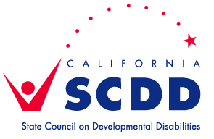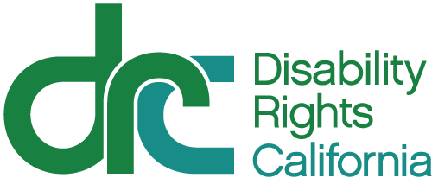

Please join SCDD-Sacramento &
DRC’s Office of Clients’ Rights Advocacy for the following workshop:

How To Read My IEP

Attend our workshop to learn how to read your child’s IEP. We will review all sections of the IEP, including the goals, services, and notes pages. We will also discuss strategies to create the best IEP possible. Please be sure to bring your child’s most recent IEP!

Saturday, January 30, 2016

9:00- 10:00 Overview of the IEP Document
10:00-11:00 Q & A

Location: SCDD Sacramento Office
2033 Howe Avenue, Ste. 160, Sacramento, CA 95825.

This training is free of charge, but RSVPs are required.
Please let us know if you need interpreting or
any special accommodations. Spanish speaking staff will be available to give the presentation in Spanish – please let us know if you prefer this when you RSVP.

To RSVP, please email: sonya.bingaman@scdd.ca.gov or
call 916-263-3085 & provide your name, email address, and phone number. Space is limited.

Please share flyer with others who may be interested!

