Headquarters
3831 North Freeway Blvd. #125
Sacramento, CA 95834
(916) 263-7919
Toll Free: (833) 818-9886

Regional Offices

North Coast
505 S. Street
Ukiah, CA 95482
(707) 463-4700

North State
80 Independence Circle, #210
Chico, CA 95973
(530) 895-4027

Sacramento
3831 North Freeway Blvd. #125
Sacramento, CA 95834
(916) 263-
North Bay
236 Georgia Street, Suite 201
Vallejo, CA 94590
(707) 648-4073
Bay Area
1515 Clay Street, Suite 300
Oakland, CA 94612
(510) 286-0439
North Valley Hills
2529 West March Lane, Suite 105
Stockton, CA 95207
(209) 473-6930
Central Coast
2580 North First Street, Suite 240
San Jose, CA 95131
(408) 324-2106
Sequoia
770 East Shaw Avenue, Suite 123
Fresno, CA 93710
(559) 222-2496

Los Angeles
411 N. Central Avenue, Suite 620
Glendale, CA 91203
(818) 543-4631

Santa Ana
2000 E. Fourth Street, Suite 115
Santa Ana, CA 92705
(714) 558-4404

San Bernardino
2000 E. Fourth Street, Suite 115
Santa Ana, CA 92705
(714) 558-4404

San Diego Imperial
8880 Rio San Diego Dr., Suite 1015
San Diego, CA 92108-1634
(619) 688-3323
“The Council advocates, promotes & implements policies and practices that achieve self-determination, independence, productivity & inclusion in all aspects of community life for Californians with developmental disabilities and their families."
WWW.SCDD.CA.GOV
S t a t e C o u n c i l o n D e v e l o p m e n t a l D i s a b i l i t i e s
Gavin Newsom
Governor
STATE OF CALIFORNIA

Hello John Smith,

I am writing to you from the State Council on Developmental Disabilities. We have been asked to interview people who receive services from the Regional Center. Your Service Coordinator is aware that we will be calling you.

A surveyor named Sally Jones will be calling you in the next few days to plan a time to talk.
The survey will take about 45-60 minutes and Sally will talk to you face to face over the computer using Zoom. You will need a device to talk to us. Sally will text or email you an invite. On the other side of this page are instructions on how to join the Zoom meeting.
The survey is not a test and there is no right or wrong answer.
Taking part in the survey is voluntary. If you do not want to participate, you can tell the surveyor at any time.
All information will be kept confidential and your answers will not be shared with your Service Coordinator.

Your answers will be used to improve services throughout the State.
If you want to see a picture of Sally before the interview, go to scdd.ca.gov/interviewer-photo-gallery and enter the password: showme. Any problems with this link, please call (714) 558-4421 or email QAProject@scdd.ca.gov

If you have any other questions, please call me at 555-555-5555.
Sincerely,

Serena Williams
Quality Assessment Coordinator
Bay Area Regional Office
xxxxx@scdd.ca.gov

Joining a Zoom Meeting/Webinar

Join by Email/Calendar Invitation
Click the “Join Zoom Meeting” link (Highlighted in the example below) in your email or calendar invitation. [Below is just an example of what you will be seeing]

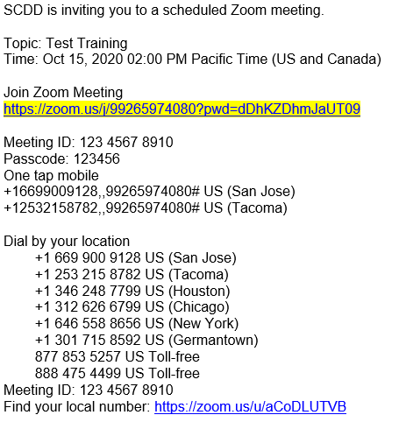

Depending on your default web browser, you may be prompted to open Zoom. Click on “Open Zoom Meetings”

